**Sufia Khatun's journey for self-dependency**

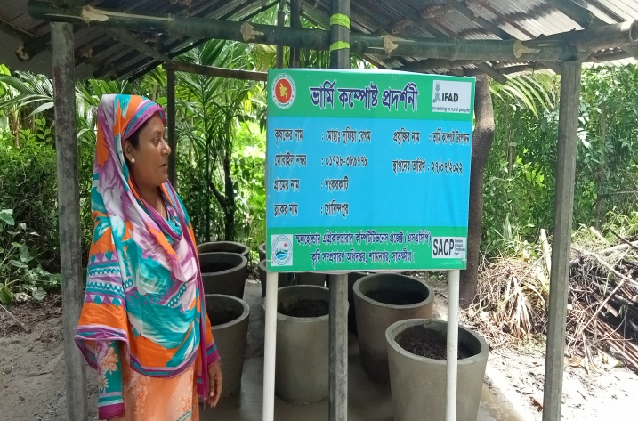Sufia Khatun (Cell phone number- 01728-389778, BID-SACP-018-06-20), wife of Abdul Jalil Gazi is basically a smallholder farmer owning only four bighas of cultivable land. She has been living in the Shankarkati village, Kashimari Union of Shyamnagar Upazilla under the Sathkhira District. Before being selected as a demonstration farmer, she received comprehensive hands-on training on Vermi-Compost production under the Smallholder Agricultural Competitiveness Project (SACP) of the Ministry of Agriculture (MOA). As a result, she learned meticulously about modern production technology on various Vermi Compost and high-value crops. She also gathered knowledge on market management, post-harvest management and primary processing of high-value crops from another marketing-related training under the project. Being experienced by this knowledge and skill, test basis she started Vermi compost production, selling and first time earned a handsome amount.

In the meantime, her husband fell sick and could not able to earn for the family. Then Sufia Khatun has to work intensively to bear children’s education, food and treatment cost. As Sufia Khatun was not having enough asset and land, so, she falls in difficult for maintaining her family expenses as per requirement. However, in spite of the crisis, she moves forward with her willpower, skill and hard work. She said, ‘I have to work as domestic worker to meet my family expenses. But I did not lose mental strength. I keep on believing on my skills and experience.’ Her believe expedite her to use own strength.

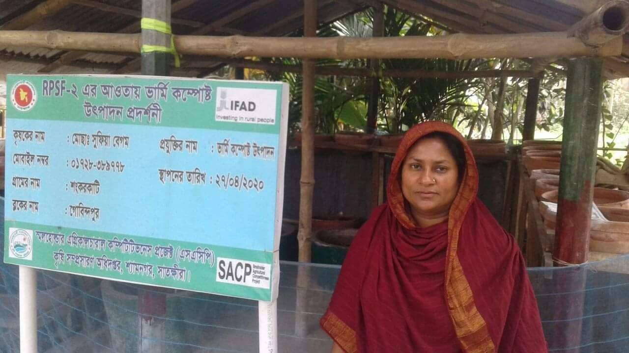Sufia Khatun again met SACP staff Samsur Rahman and then Sufia along with her group members (consists of 25 women) attended in a demonstration program organized by the SACP. Again she learned from SACP regarding HVC Vegetables production and organic agriculture practice issues. Observing Sufia's interest and demand SACP provided her material support (ring slab and mother earth worm) so that she could prepare the compost and continue work. Finally, Sufia Khatun started producing vermi compost in a small scale. Besides, seeing her interest in this work, Shyamnagar Upazila Agriculture Office also supported her as and when required. With those supports and own determination, Sufia got speed and energy; she sells the compost in the market and earns cash which helps her to meet the family expenses.

Today she is well-known entrepreneur among other farmers. As a result, her neighbors also get interested in making vermi compost and meet Sufia for help. Sufia highlighted the importance of earthworm compost and motivated them to use it. Interested people in the surrounding areas demanding for earthworm compost to Sufia Khatun and accordingly she is increasing compost production gradually. She said, ‘I started selling compost fertilizer at the rate of taka 13-15 per kg. After a few days, when quantity of earthworms increased, I started selling earthworms at the rate of Tk 700-800 per mond; that is 17.5 to 20 taka per kg'. Being involved with the vermi compost business, she got enable to minimize her hardship.

Apart from their own village, people from nearby villages came to buy compost from Sufia Khatun today. Currently, Sufia Khatun earns 18-20 thousand (18000-20000) taka per month only by selling Vermi compost fertilizer and mother seeds of earthworms. Sufia Khatun said that she is not the only one who benefited from the production and sale of Vermi compost fertilizer in Shankarkati village. Most of the families in her village are currently involved in the production and use of earthworm compost. This year Sufia Khatun's village- Shankarkati of Shyamnagar Upazilla under Sathkhira district is going to be declared as vermi compost village by Shyamnagar Agricultural Office. Presently, many families in the village are involved in organic farming practices. An enterprising woman’s own initiative, efforts and skills have not only provided financial security to her family, but also made an outstanding contribution to socio-environmental change and enhanced her social status. Sufia Khatun is as shining women entrepreneur and organic farming practitioner of that village now.